**SheCodes Project 1**

**Cath Leighton**

**Submission**

Please submit the following:

* A link to your website. <https://cath11.github.io/index.html>
* A link to its repository. <https://github.com/Cath11/cath11.github.io>
* Screenshots showing (see pages below)
* The different pages and features of your website on mobile, tablet and desktop screen sizes (multiple screenshots per page and screen size).
* The different features of your site, e.g. if you have hover states, take a screenshot that shows that.

**Home Page-desktop version (1200+ screen)**

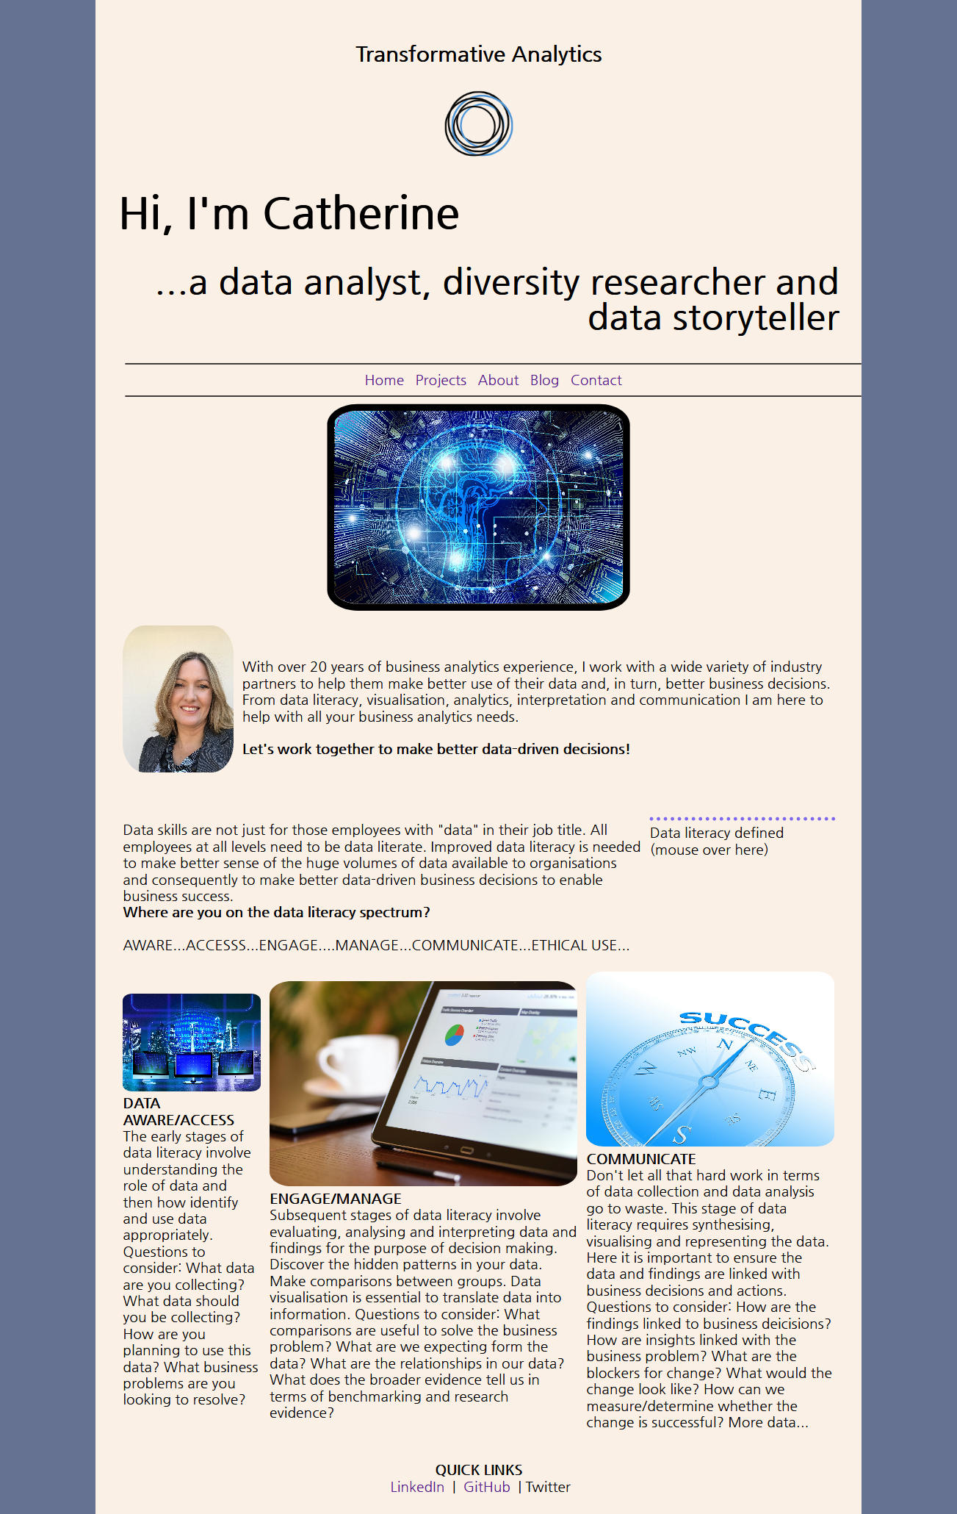

Check out the hover…



Check out the hover!

…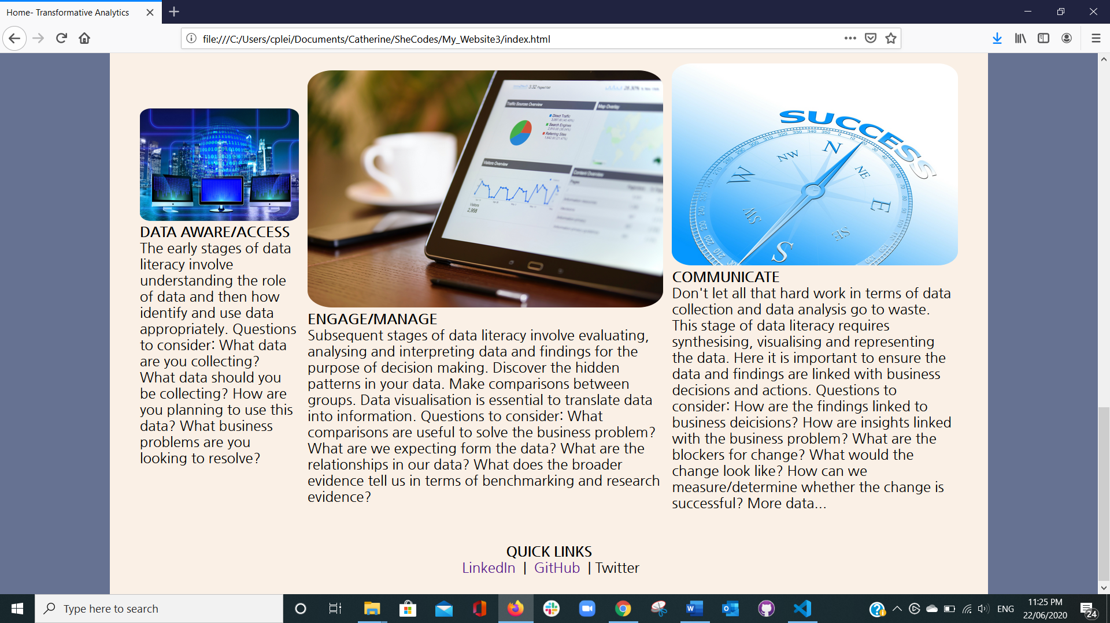…

Another hover and links to my LinkedIn profile. The GithHub link works too!

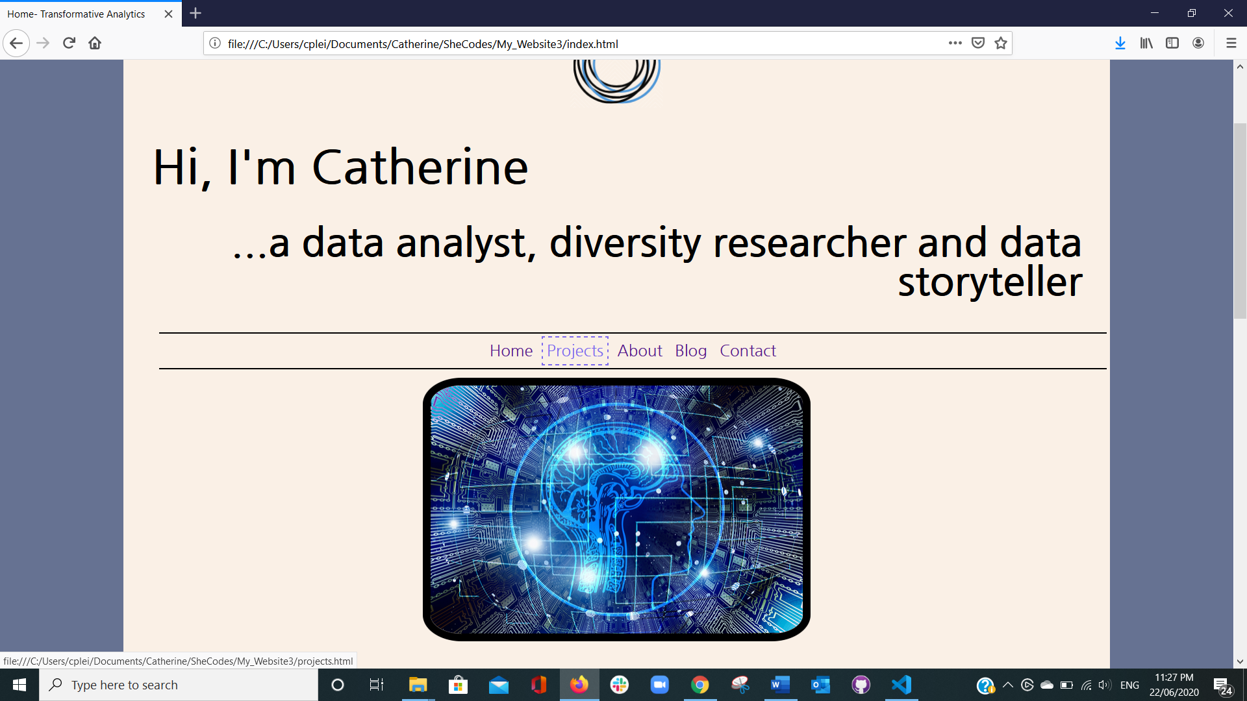

Another hover and links to my other webpages from the home page. Loving the hover!

Projects page

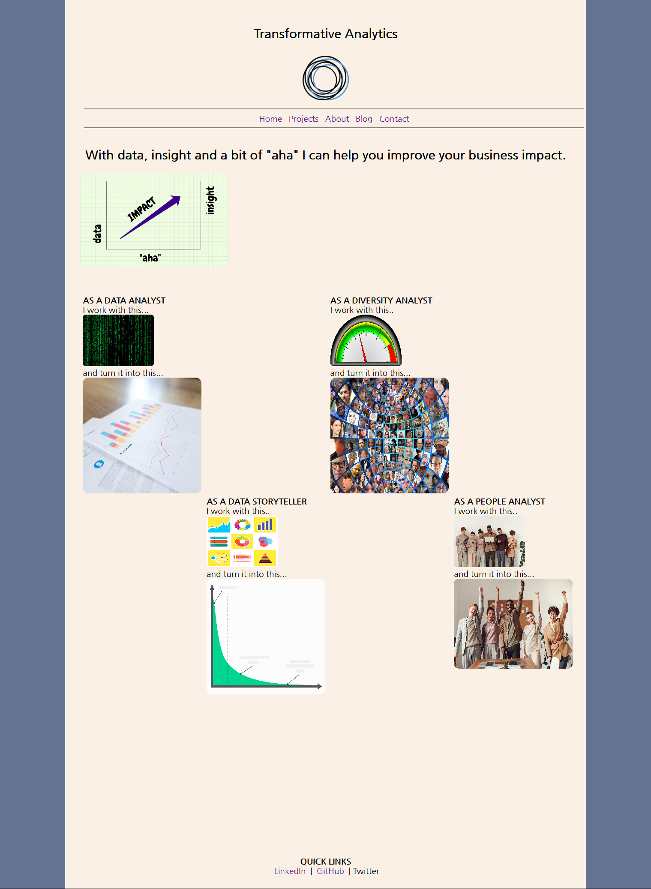

About page

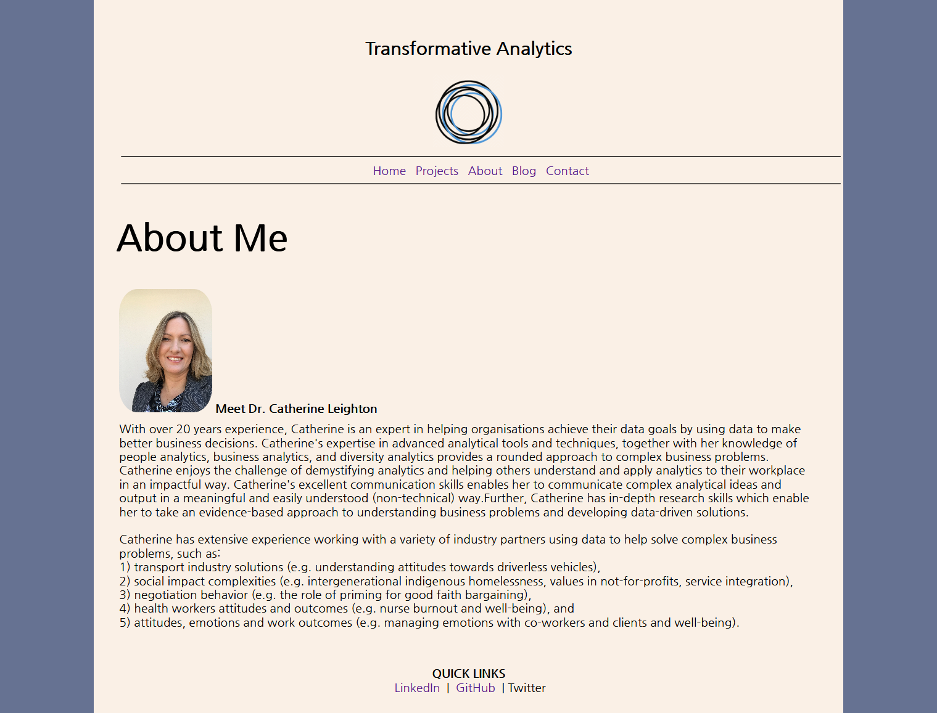

Blog page (sorry a bit empty)

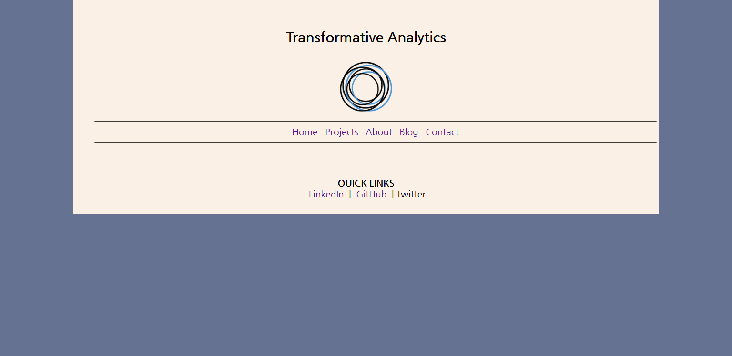

Contact page (full functioning i.e. linked to Formspree and working)

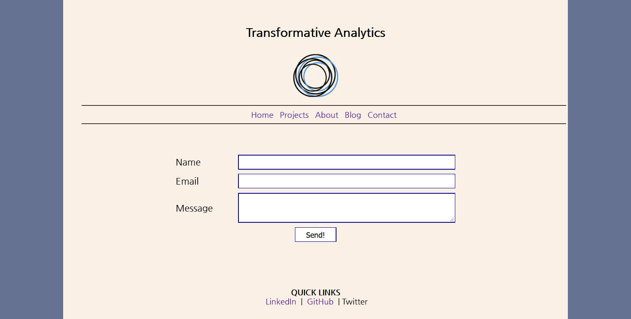

Check out the hover over the send button (this is where my love for hover began)

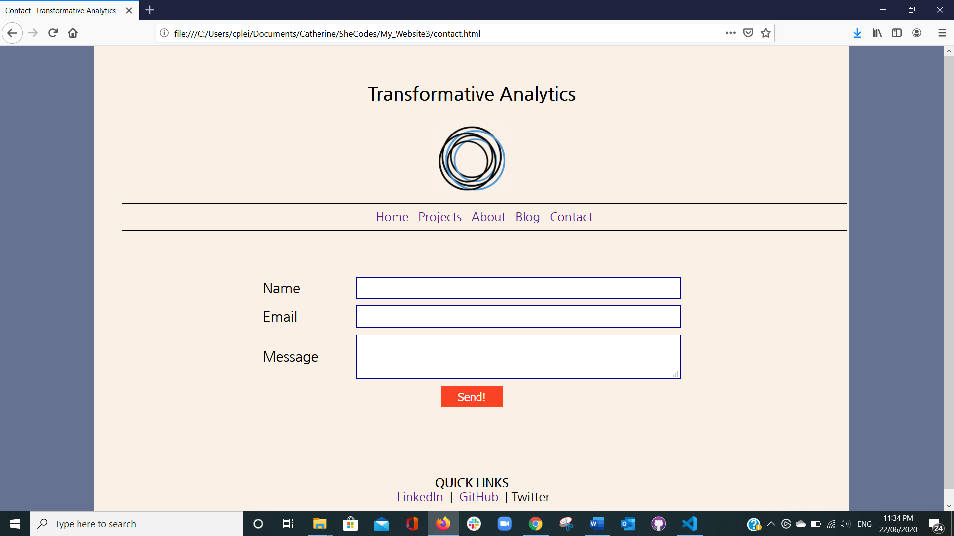

**Home page--Responsive mode-iPad version (width 768 portrait)**



Note: hover still works

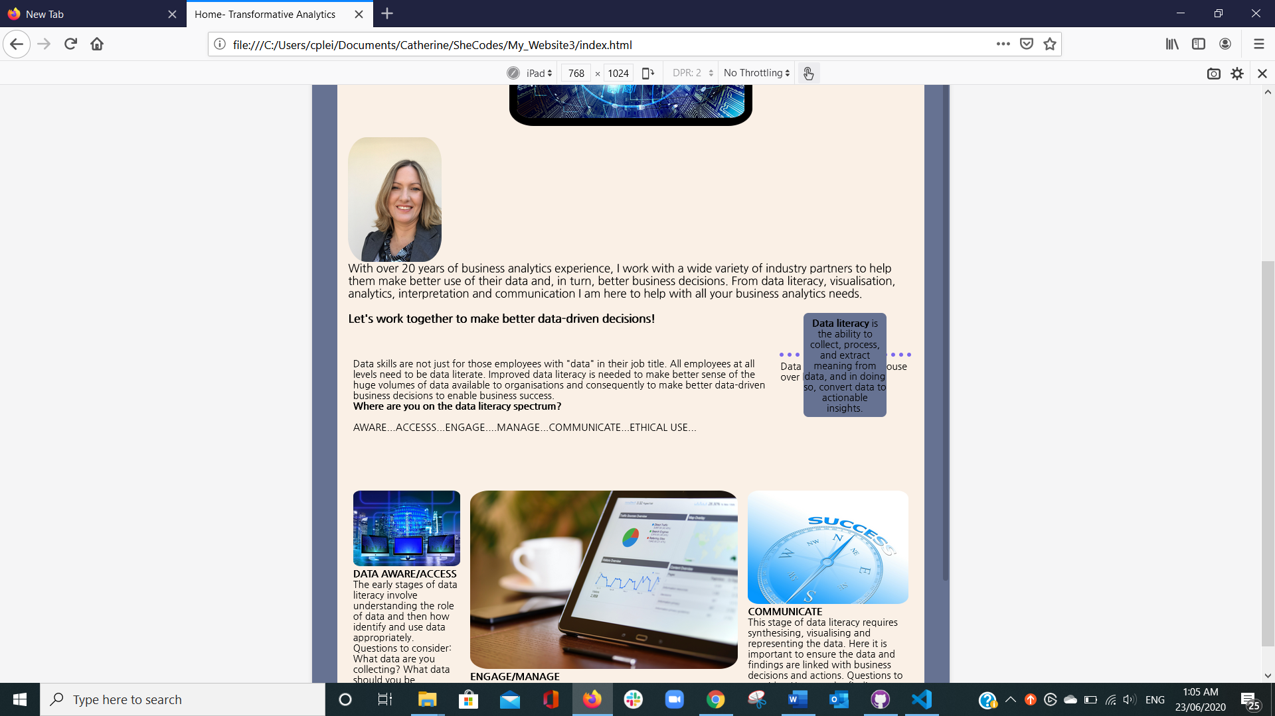

Contact Page

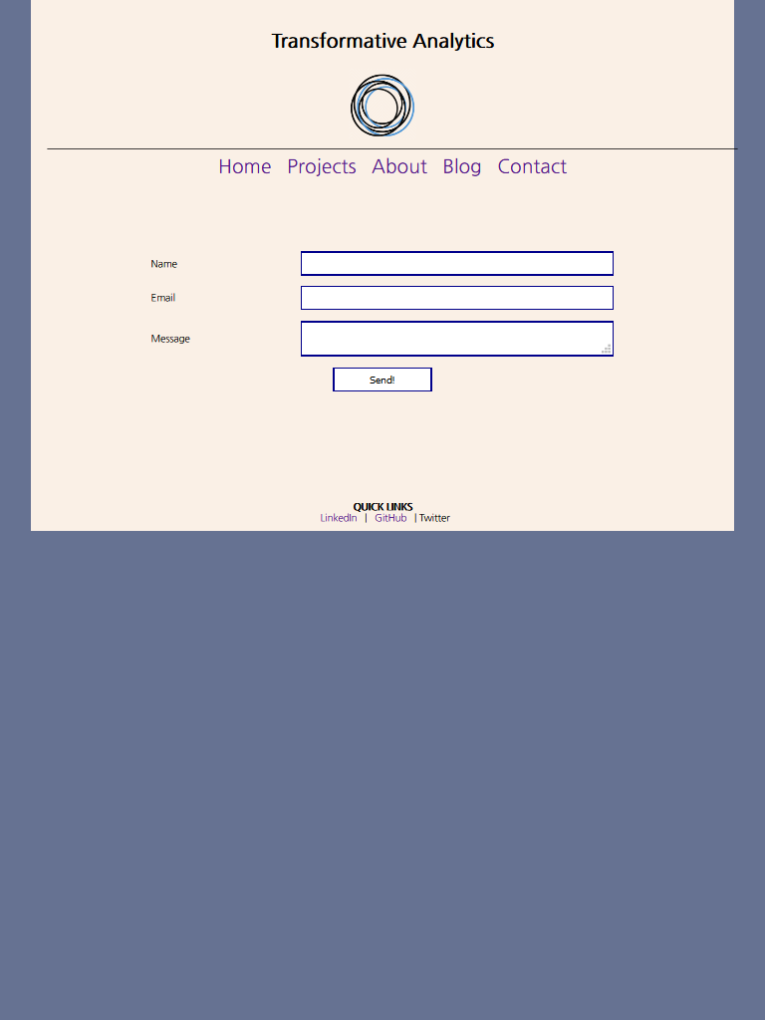

About page

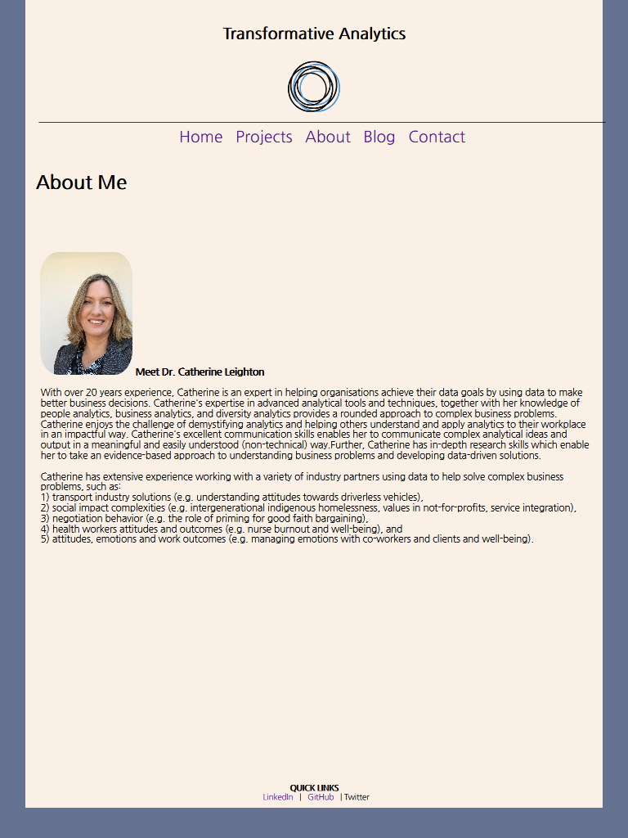

Project page

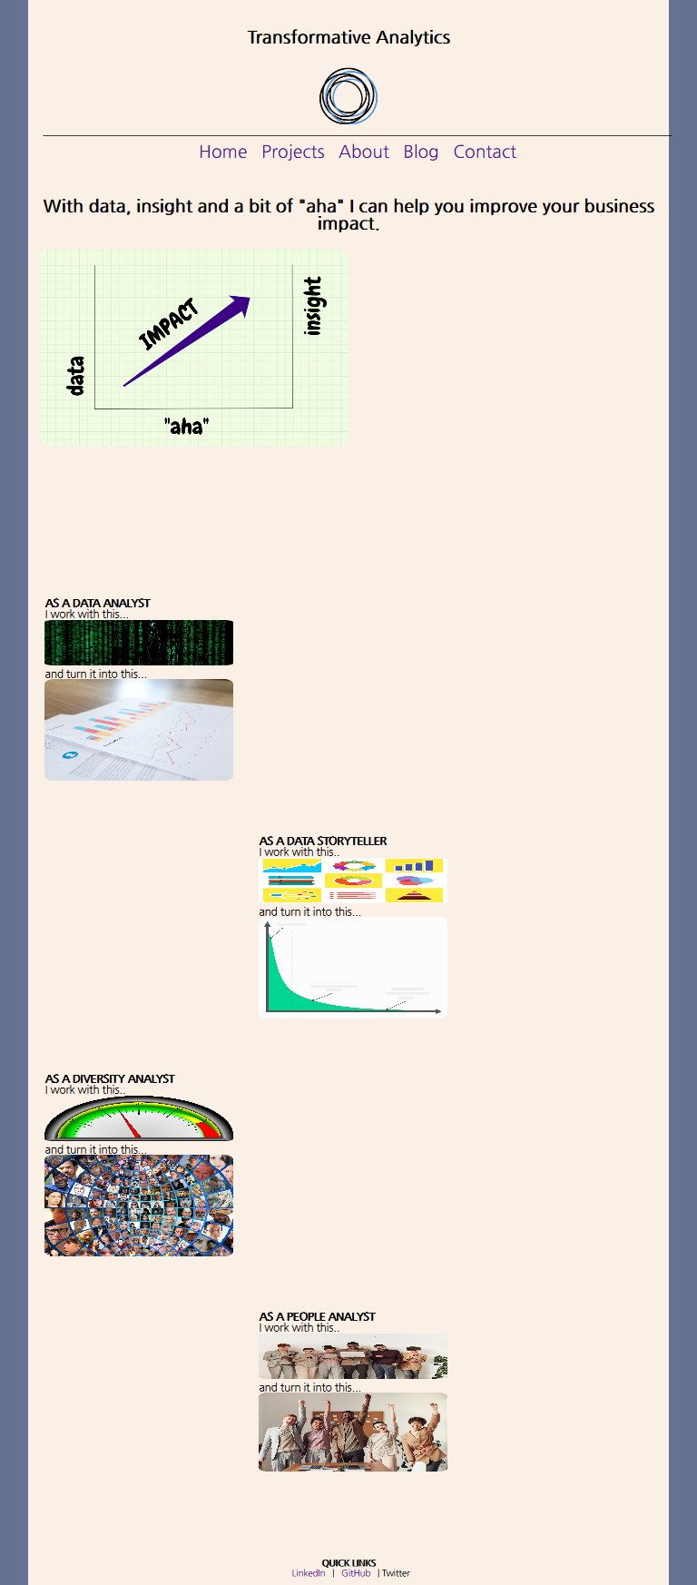

**Home page--Responsive mode-iPhone 6/7/8 version (width 375 portrait)**

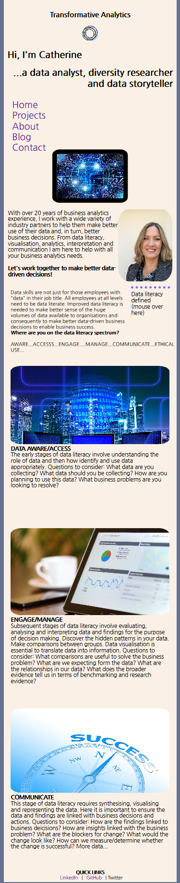

Home page with hover working

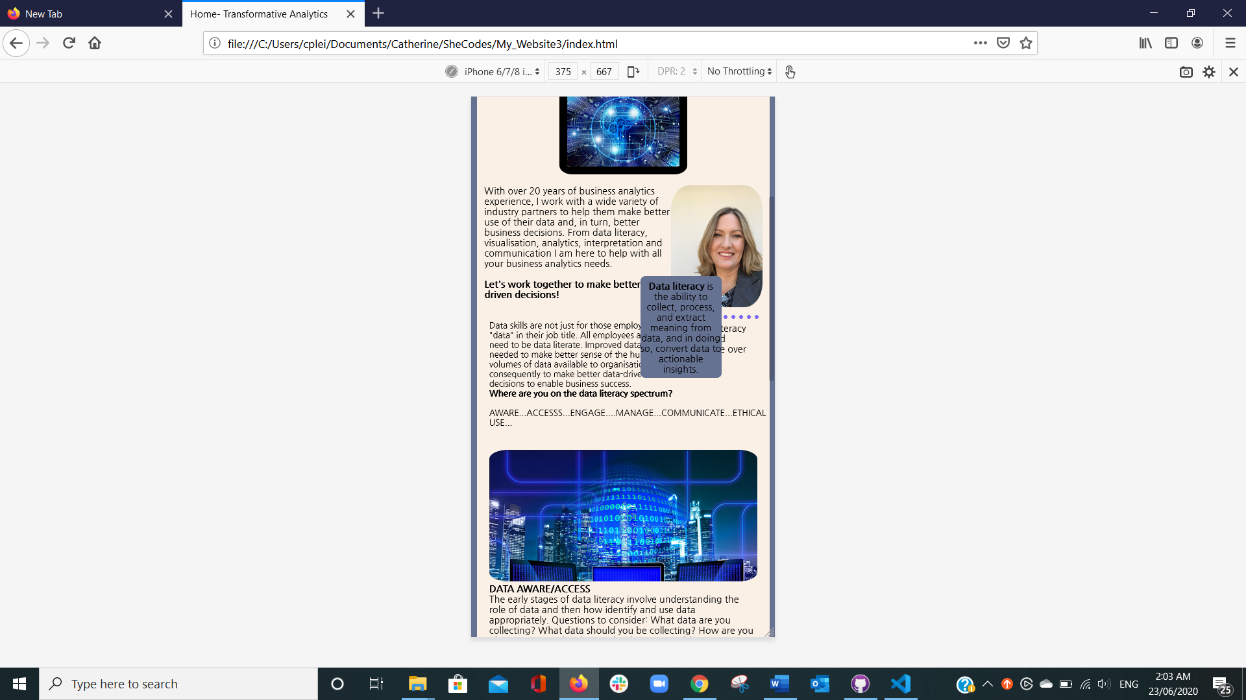

Projects page

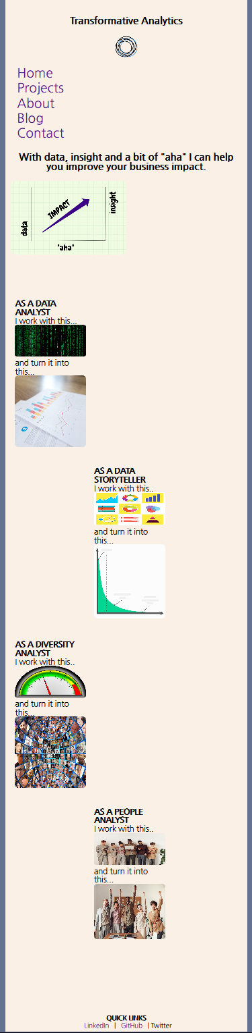

About Page

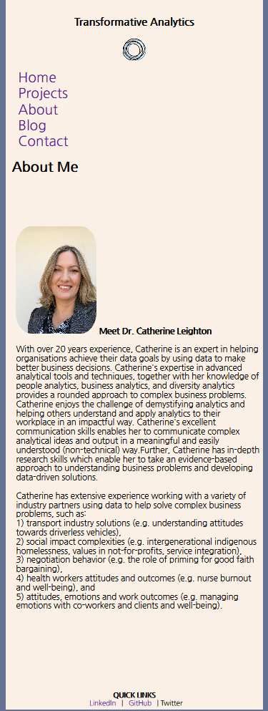

Contact Page

